
VISVESVARAYA TECHNOLOGICAL UNIVERSITY

Belagavi – 590018, Karnataka INTERNSHIP REPORT

on
“STOCK PORT PREDICTIVE SENTIMENT ANALYSIS”
Submitted in partial fulfillment for the award of the degree

BACHELOR OF ENGINEERING IN
Computer science and engineering
Submitted by:
NAME :M Soujanya
USN : 1JS20CS085

Conducted at
VARCONS Technologies Pvt Ltd



JSS Acadamy of Technical Education
Department of Computer Science and Engineering Accredited by NAAC, Bangalore.
Dr.Vishnuvardhan Rd Uttarahalli-Kengeri Main Road, JSS Campus Rd, Srinivaspura, Bengaluru, Karnataka 560060

CERTIFICATE

This is to certify that the Internship titled “Stock port predictive SENTIMENTAL analysis ” carried out by Ms. M Soujanya, bonafide student of JSS Acadamy of Technical Education, in partial fulfillment for the award of Bachelor of Engineering, in Computer science and engineering under Visvesvaraya Technological University,Belagavi, during the year 2022-2023. It is certified that all corrections/suggestions indicated have been incorporated in the report.

The project report has been approved as it satisfies the academic requirements in respect of the Internship prescribed for the course Internship.

Signature of Guide Signature of HOD Signature of Principal

External Viva:

Name of the Examiner Signature with Date

1)

2)

DECLARATION

I, Ms. M Soujanya , Third year student of Computer science and engineering, JSSATEB,560060, declare that the Internship has been successfully completed, in VARCONS Technologies Pvt Ltd. This report is submitted in partial fulfillment of the requirements for the award of a Bachelor’s Degree in Information science and engineering during the academic year 2022-2023.

Date:
Place:

NAME: M Soujanya
USN : 1JS20CS085

OFFER LETTER



ACKNOWLEDGEMENT

I’m happy to present this Internship after completing it successfully. This Internship would not have been possible without many individuals' guidance, assistance and suggestions. We would like to express my deep sense of gratitude and indebtedness to each and everyone who has helped me to make this project a success.

I heartily thank our Principal, Dr. BHIMASEN SORAGAON
for his constant encouragement and inspiration in taking up this Internship.

I heartily thank our Head of the Department, Dr. Naveen N C
, Dept. of Computer science and engineering, JSS Acadamy of Technical Education for his constant encouragement and inspiration in taking up this Internship.

I gratefully thank the Project guide, Dr. , Assistant Professor, Department of Computer science and engineering, for their encouragement and advice throughout the course of the Project work.

Special thanks to all the staff members of the Computer science and engineering Department for their help and kind cooperation.

Lastly, I thank my parents and friends for their encouragement and support given us in order to finish this precious work.

M Soujanya

1JS20CS085

ABSTRACT

Prediction in machine learning refers to the output of an algorithm after it has been trained on a historical data set and applied to new data when forecasting the likelihood of a particular outcome.
In this project, we investigate the impact of sentiment expressed through Twitter tweets on stock price prediction. Twitter is the social media platform which provides a free platform for each individual to express their thoughts publicly. Specifically, we fetch the live twitter tweets of the particular company using the API. All the stop words, special characters are extracted from the data set. The filtered data is used for sentiment analysis using Naïve bayes classifier. Thus, the tweets are classified into positive, negative and neutral tweets. To predict the stock price, the stock data set is fetched from yahoo finance API. The stock data along with the tweets data are given as input to the machine learning model to obtain the result. LSTM deep learning algorithm is used as a model to predict the stock market price. The obtained prediction value is compared with the actual stock market value. The effectiveness of the proposed project on stock price prediction is demonstrated through experiments on several companies like Apple, Amazon, Microsoft using live twitter data and daily stock data.

Table of Contents

Sl no | Description | Page no
1 | Company Profile | 8
2 | About the Company | 9-11
3 | Introduction | 12
4 | System Analysis | 13-14
5 | Requirement Analysis | 15
6 | Design Analysis | 16-17
7 | Implementation | 18-20
8 | Snapshots | 21-23
9 | Conclusion | 24
10 | References | 25

CHAPTER 1. COMPANY PROFILE

A Brief History of VARCONS Technologies Pvt Ltd.
VARCONS Technologies Pvt Ltd was incorporated with a goal of” To provide high quality and optimal Technological Solutions to business requirements of our clients”. Every business is different and has a unique business model and so are the technological requirements. They understand this and hence the solutions provided to these requirements are different as well. They focus on client’s requirements and provide them with tailor-made technological solutions.They also understand that the Reach of their Product to its targeted market or the automation of the existing process into e-client and simple process are the key features that our clients desire from Technological Solution they are looking for and these are the features that we focus on while designing the solutions for their clients.
Sarvamoola Software Services. is a Technology Organization providing solutions for all web design and development, MYSQL, PYTHON Programming, HTML, CSS, ASP.NET, and LINQ? Meeting the ever-increasing automation requirements, Sarvamoola Software Services. specialize in ERP, Connectivity, SEO Services, Conference Management, effective webpromotion, and tailor-made software products, designing solutions best suiting client’s requirements.
VARCONS Technologies Pvt Ltd, strive to be the front runner in creativity and innovation in software development through its well-researched expertise and establish it as an out-of-the-box software development company in Bangalore, India. As a software development company, they translate this software development expertise into value for their customers through their professional solutions.
They understand that the best-desired output can be achieved only by understanding the client’s demand better. VARCONS Technologies Pvt Ltd work with their clients and help them to define their exact solution requirement. Sometimes even they wonder if they have completely redefined their solution or new application requirement during the brainstorming session, and here they position themselves as an IT solutions consulting group comprising of high-caliber consultants.

They believe that Technology when used properly can help any business to scale and achieve new heights of success. It helps Improve its efficiency, profitability, and reliability; to put it in one sentence” Technology helps you to Delight your customers” and that is what we want to achieve.

CHAPTER 2. ABOUT THE COMPANY


VARCONS Technologies Pvt Ltd is a Technology Organization providing solutions for all web design and development, MYSQL, PYTHON Programming, HTML, CSS, ASP.NET, and LINQ. Meeting the ever-increasing automation requirements, VARCONS Technologies Pvt Ltd specializes in ERP, Connectivity, SEO Services, Conference Management, effective webpromotion, and tailor-made software products, designing solutions best suiting client’s requirements. The organization where they have the right mix of professionals as a stakeholder to help us serve our clients to t he best of our capability and with at par industry standards.They have young, enthusiastic, passionate, and creative Professionals to develop technological innovations in the field of Mobile technologies, Web applications as well as Business and Enterprise solutions. The motto of our organization is to “Collaborate with our clients to provide them with best Technological solution hence creating Good Present and Better Future for our client which will bring a cascading a positive effect in their business shape as well”. Providing a Complete suite of technical solutions is not just our tag line, it is Our Vision for Our Clients, and for Us, and we strive hard to achieve it.

Products of VARCONS Technologies Pvt Ltd.
Android Apps

It is the process by which new applications are created for devices running the Android operating system. Applications are usually developed in Java (and/or Kotlin; or other such option) programming language using the Android software development kit (SDK), but other development environments are also available, some such as Kotlin support the exact same Android APIs (and bytecode), while others such as Go have restricted API access.
The Android software development kit includes a comprehensive set of development tools. These include a debugger, libraries, a handset emulator based on QEMU, documentation, sample code, and tutorials. Currently supported development platforms include computers running Linux (any modern desktop Linux distribution), Mac OS X 10.5.8 or later, and Windows 7 or later. As of March 2015, the SDK is not available on Android itself, but software development is possible by using specialized Android applications.
Web Application

It is a client-server computer program in which the client (including the user interface and

client-side logic) runs in a web browser. Common web applications include webmail, online
retail sales, online auctions, wikis, instant messaging services, and many other functions. web applications use web documents written in a standard format such as HTML and JavaScript, which are supported by a variety of web browsers. Web applications can be considered as a specific variant of client-server software where the client software is downloaded to the client machine when visiting the relevant web page, using standard procedures such as HTTP. The Client web software updates may happen each time the web page is visited. During the session, the web browser interprets and displays the pages, and acts as the universal client for any web application. The use of web application frameworks can often reduce the number of errors in a program, both by making the code simpler and by allowing one team to concentrate on the framework while another focuses on a specified use case. In applications that are exposed to constant hacking attempts on the Internet, security-related problems can be caused by errors in the program.
Frameworks can also promote the use of best practices such as GET after POST. There are some who view a web application as a two-tier architecture. This can be a “smart” client that performs all the work and queries a “dumb” server, or a “dumb” client that relies on a “smart”server. The client would handle the presentation tier, the server would have the database (storage tier), and the business logic (application tier) would be on one of them or on both. While this increases the scalability of the applications and separates the display and the database, it still doesn’t allow for true specialization of layers, so most applications will outgrow this model. An emerging strategy for application software companies is to provide web access to software previously distributed as local applications. Depending on the type of application, it may require the development of an entirely different browser-based interface, or merely adapting an existing application to use a different presentation technology. These programs allow the user to pay a monthly or yearly fee for use of a software application without having to install it on a local hard drive. A company that follows this strategy is known as an application service provider (ASP), and ASPs are currently receiving much attention in the software industry.
Security breaches in these kinds of applications are a major concern because it can involve both enterprise information and private customer data. Protecting these assets is an important part of any web application and there are some key operational areas that must be included in the development process. This includes processes for authentication, authorization, asset handling, input, and logging and auditing. Building security into the applications from the beginning can be more effective and less disruptive in the long run.
Web design

It encompasses many different skills and disciplines in the production and maintenance of
websites. The different areas of web design include web graphic design; interface design; authoring, including standardized code and proprietary software; user experience design; and search engine optimization. The term web design is normally used to describe the design process relating to the front-end (client side) design of a website including writing markup. Web design partially overlaps web engineering in the broader scope of web development. Web designers are expected to have an awareness of usability and if their role involves creating marks up then they are also expected to be up to date with web accessibility guidelines. Web design partially overlaps web engineering in the broader scope of web development.

Departments and services offered
VARCONS Technologies Pvt Ltd plays an essential role as an institute, the level of education, and development of student’s skills are based on their trainers. If you do not have a good mentor then you may lag in many things from others and that is why we at VARCONS Technologies Pvt Ltd give you the facility of skilled employees so that you do not feel unsecured about your academics. Personality development and academic status are some of those things which lie in the mentor’s hands. If you are trained well then you can do well in your future and knowing the importance of VARCONS Technologies Pvt Ltd always tries to give you the best.
They have a great team of skilled mentors who are always ready to direct their trainees in the best possible way they can and to ensure the skills of mentors we held many skills development programs as well so that each and every mentor can develop their own skills with the demands of the companies so that they can prepare a complete packaged trainee.

Services provided by VARCONS Technologies Pvt Ltd.
- Core Java and Advanced Java

- Web services and development

- Dot Net Framework

- Python

- Selenium Testing

- Conference / Event Management Service

- Academic Project Guidance

- On The Job Training

- Software Training

CHAPTER 3. INTRODUCTION

Introduction to ML

In this model, we test a hypothesis based on the premise of behavioral economics, that the emotions and moods of individuals aﬀect their decision making process, thus, leading to a direct correlation between ”public sentiment” and ”market sentiment”. We perform sen- timent analysis on publicly available Twitter data to ﬁnd the public mood and the degree of membership into 3 classes- Positive,Negative,Neutral. We use these moods and previous days’ Stock price data to predict future stock movements and then use the predicted values in our portfolio management strategy.

Problem Statement
Stock exchange is a subject that is highly affected by economic, social, and political factors. There are several factors e.g. external factors or internal factors which can affect and move the stock market. Stock prices rise and fall every second due to variations in supply and demand. Various Data mining techniques are frequently involved to solve this problem. But techniques using machine learning will give a more accurate, precise and simple way to solve such issues related to stock and market prices.“Stock Price Prediction Using Twitter Sentiment Analysis” a method for predicting stock prices is developed using news articles. The changes in stock prices of a company, the rises and falls, are correlated with the public opinions being expressed in tweets about that company. Understanding people's opinion from a piece of text is the objective of sentiment analysis. Positive news and tweets in social media about a company would definitely encourage people to invest in the stocks of that company and as a result the stock price of that company would increase. A prediction model for finding and analyzing correlation between contents of tweets and stock prices and then making predictions for future prices can be developed by using machine learning.

CHAPTER 4. SYSTEM ANALYSIS

Existing system

In the last decade, sentiment analysis has carried great importance because of the huge amount of textual data on news and social media platforms. There is a signiﬁcant amount of research on mining opinions of users for different application areas . Ali performed sentiment analysis to detect transportation entities in the large corpus and to detect trafﬁc accidents to reduce serious injuries [43]. Basiri proposed a sentiment analysis method on the Twitter dataset using the attention-based bidirectional CNN-RNN deep model. Li proposed a bidirectional emotional recurrent unit for exploring the emotion in conversation. Using the same trend for stock prediction, some researchers have started to utilize sentiment analysis to analyze the stock market’s movements. In 2011, J. Bollen proposed a sentiment analysis method to predict the movement of the Dow Jones Industrial Average (DJIA) stock market based on the famous microblogging site Twitter. Khatri and Srivastava explored the relationship between text sentiment from tweets, comments on the Stock Twist website, and the stock price of Facebook, Apple, Google, Oracle, and Microsoft stocks from Yahoo Finance. In 2017, Urolagin used an SVM classiﬁer to perform sentiment classiﬁcation and predict stock market status based on stock price data from Yahoo Finance and social-media data from Twitter. He explored an association between tweet features and the stock prices of a company. Not long after that, Chakraborty proposed a stock-market-movement prediction model based on tweets sentiment of NETFLIX stock. The SVM classiﬁer was used for sentiment classiﬁcation,while the stock movement prediction model was trained by applying the boosted regression tree. In 2020, Khan utilized algorithms on social media and ﬁnancial news data to discover the impact of both data on stock movement.

2.Proposed System

This section explains the proposed methodology, the standard dataset fr, LSTM model.

Transfer Learning

Transfer learning is one of the machine learning models which uses the knowledge gained from solving one problem is incorporated to solve another problem. It is evident that Transfer learning solves many problems within short intervals of time. Transfer Learning is incorporated whenever there is any need to reduce computation cost, achieve accuracy with less training

Preparation of Training Dataset

Stock data extracted is not completely understandable because of public holidays and weekends where the stock market does not function.There are missing in the stock value. These empty values can be approximately used in a simple way. Consider, the stock value on a day is x and the next value present is y with some missing in between. So, the first value is estimated as (y+2)/2 and the same method is used to fill the missing values.Extracted tweets contain many stop words, unnecessary data like special characters, URLs, pictures. These tweets are pre-processed to obtain the emotion of the public. For pre-processing of data, we employ three steps of filtering:Tokenization: Each tweet is split into individual words called tokens. This process is done to break the text, separated by whitespace characters. Removal of stop words: Words like “a”, “an”, “the”, “he”, “she”, “by”, “on”, etc are not required for sentiment analysis. These are called stop words, which is removed before the sentiment analysis process. Regex Matching: Special characters such as “URL”, “!”, “#”, “@” are all removed and replaced by whitespaces.

Objective of the System

In the past decade, a lot of research has gone into Stock Price Prediction. The primary objective of Stock Price Prediction is to improve the predictions made by Machine learning models. Predicting the value based on past data will not return an effective prediction. Therefore we are using Twitter tweets sentiment analysis so that the effectiveness in the prediction can be achieved

CHAPTER 5. REQUIREMENT ANALYSIS

Hardware Requirement Specification

- Processor: Minimum 1 GHz; Recommended 2GHz or more
- Ethernet connection (LAN) OR a wireless adapter (Wi-Fi)
- Hard Drive: Minimum 32 GB; Recommended 64 GB or more
- Memory (RAM): Minimum 1 GB; Recommended 4 GB or above
- Sound card w/speakers
- Some classes require a camera and microphone

Software Requirement Specification

- Platform: Anaconda
- Environment: Python 3
- Modules: Matplotlib, NumPy, Pandas,Keras,Tensorflow

CHAPTER 6. DESIGN ANALYSIS

Logistic Regression

Linear Regression is a linear approach to modeling the relationship between a scalar response and one or more explanatory variables (also known as dependent and independent variables). A stock's price and time-period determine the system parameters for linear regression, making the method universally applicable. Gradient Descent algorithm is used for tuning the weights of the model to attain less

Support Vector Machines

Support Vector Machines (SVM) are supervised algorithm that works for both classification and regression problems. Support vectors are coordinate points in space, formed using the attributes of a data point. Briefly, for an N-dimensional dataset, each data point is plotted on an N-dimensional space using all its feature vector values as a coordinate point. Classification between the classes is performed by finding a hyperplane in space that clearly separates the distinct classes. SVM works best for high-dimensional data. The important aspect of implementing the SVM algorithm is finding the hyperplane. Two conditions are to be met in the order given while choosing the right hyperplane.
    - The hyperplane should classify the classes most accurately

    - The margin distance from the hyperplane to the nearest data point must be maximized

For a low dimensional dataset, the method of kernel trick in SVM introduces additional features to transform the dataset to high dimensional space and thereby make identifying the hyperplane achievable. The linear solver-based SVM is a better implementation of SVM in terms of time complexity. The complexity scales between O(n samples X n2 samples) and O(n samples X n3 samples).

LSTM

Long short-term memory (LSTM) is an artificial neural network used in the fields of artificial intelligence and deep learning. Unlike standard feedforward neural networks, LSTM has feedback connections. Such a recurrent neural network (RNN) can process not only single data points (such as images), but also entire sequences of data (such as speech or video). For example, LSTM is applicable to tasks such as unsegmented, connected handwriting recognition,speech recognition, machine translation,robot control, video games,and healthcare.LSTM has become the most cited neural network of the 20th century.The name of LSTM refers to the analogy that a standard RNN has both "long-term memory" and "short-term memory". The connection weights and biases in the network change once per episode of training, analogous to how physiological changes in synaptic strengths store long-term memories; the activation patterns in the network change once per time-step, analogous to how the moment-to-moment change in electric firing patterns in the brain store short-term memories. The LSTM architecture aims to provide a short-term memory for RNN that can last thousands of timesteps, thus "long short-term memory".
A common LSTM unit is composed of a cell, an input gate, an output gate and a forget gate.The cell remembers values over arbitrary time intervals and the three gates regulate the flow of information into and out of the cell.
LSTM networks are well-suited to classifying, processing and making predictions based on time series data, since there can be lags of unknown duration between important events in a time series. LSTMs were developed to deal with the vanishing gradient problem that can be encountered when training traditional RNNs. Relative insensitivity to gap length is an advantage of LSTM over RNNs, hidden Markov models and other sequence learning methods in numerous applications.
An LSTM module (or cell) has 5 essential components which allows it to model both long-term and short-term data. Hidden state (h_{t}) - This is output state information calculated w.r.t. current input, previous hidden state and current cell input which you eventually use to predict the future stock market prices.

CHAPTER 7. IMPLEMENTATION

Implementation is the stage where the theoretical design is turned into a working system. The Most crucial stage in achieving a new successful system and in giving confidence in the new system to the users that it will work efficiently and effectively.
The system can be implemented only after thorough testing is done and if it is found to work according to the specification. It involves careful planning, investigation of the current system and its constraints on implementation, design of methods to achieve the changeover, and an evaluation of change over methods apart from planning.
Two major tasks of preparing the implementation are education and training of the users and testing of the system. The more complex the system being implemented, the more involved will be the system analysis and design effort required just for implementation.

The implementation phase comprises several activities. The required hardware and software acquisition is carried out. The system may require some software to be developed.For this, programs are written and tested. The user then changes over to his new fully tested system and the old system is discontinued.

Data Collection
The first step in implementing the Stock Price Prediction is to collect stock data. This data includes the historic data of the company. Along with the stock data it is important to collect twitter data which provide insights on how the market opened on a particular day based on any positivity or negativity in twitter. We used Kaggle Netflix dataset which has already collected the historic twitter data for a given span and company stock data for the same span of time

Python Library

The python libraries which were used in the model building are:

import numpy as np
import tensorflow as tf
from keras.callbacks import ModelCheckpoint
from keras.models import Sequential
from keras.layers import LSTM,Conv1D,Conv2D,MaxPooling2D,MaxPooling1D,Flatten
from keras.layers import Dense, Dropout
import pandas as pd
# from keras.optimizers import Adam
from matplotlib import pyplot as plt
from sklearn.preprocessing import StandardScaler,MinMaxScaler
import seaborn as sns
#from datetime import datetime

from tensorflow.compat.v1.keras.layers import CuDNNLSTM,Bidirectional

7.3 Data Visualization
Visualizing the data gives more understanding of the problem and the type of solution to be built. The distribution of classes, the number of instances under each category, the spread of the data, and the correlation between the features and clustering are a few methods to visualize the data. Python and R provide statistical functions for data visualization.

7.4 Feature Analysis

Primarily, we are importing the required modules for the model to work,

import seaborn as sns
plt.figure(figsize=(25,7));
sns.lineplot(x=df["date"],y=df["Adj Close"])
df['sentiment_analysis']=df['P_mean']
df['sentiment_analysis']=df['sentiment_analysis'].apply(lambda x: 'pos' if x>0 else 'nue' if x==0 else 'neg')
sns.scatterplot(x=df["date"],y=df['Adj Close'],hue=df['sentiment_analysis'],palette=['y','r','g'])
plt.xticks(rotation=45);
plt.title("Stock market of Netfilx from Jan-2018 to Jul-2022",fontsize=16);

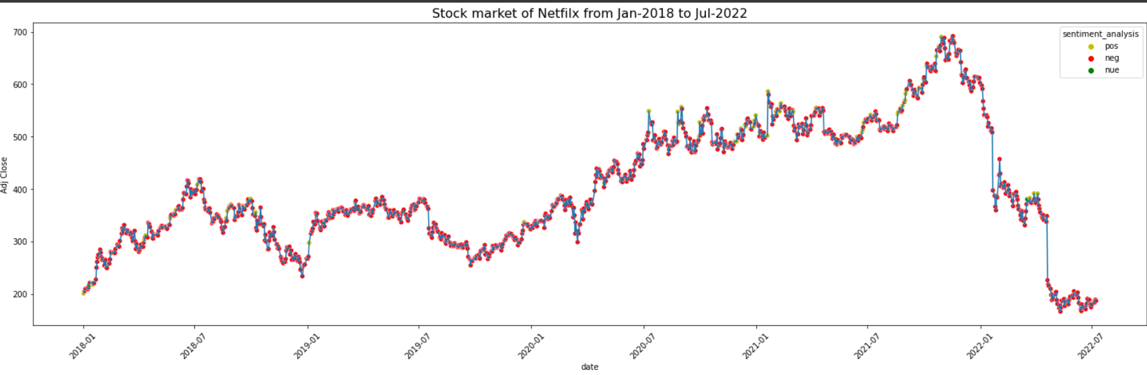

And the result is in the Table 1.1
Table 1.1

Algorithm | Accuracy
LSTM(without twitter data) | 45.52%
LSTM(with twitter data) | 67.16%

7.5 TESTING

Once training of the model is done,it is important to test the model’s accuracy of the data which is not used while training.This broad purpose of this exercise has been to arrive at trading strategies which could help in the real-world application of the models developed. The study could not approach to those levels due to several constraints and limitations as described above. Two Regressor that were used viz LSTM and Random Forest have been used to predict the next day value and the RMSEs are considered as the evaluation metrics. Since this was a regression exercise prediction with certain confidence levels couldn’t be achieved. Thus, a simple intuitive analysis of RMSE values was carried out to gauge the appropriateness of the values predicted by our models. The results as achieved from the models are indicated below

Algorithm for different scenario | MSE error
LSTM-open(without tweets) | 162.333
LSTM-open(with tweets) | 87.6900
LSTM-close(without tweets) | 175.9912
LSTM-close(with tweets) | 122.3798

CHAPTER 8. SNAPSHOTS

Feature Scaling: 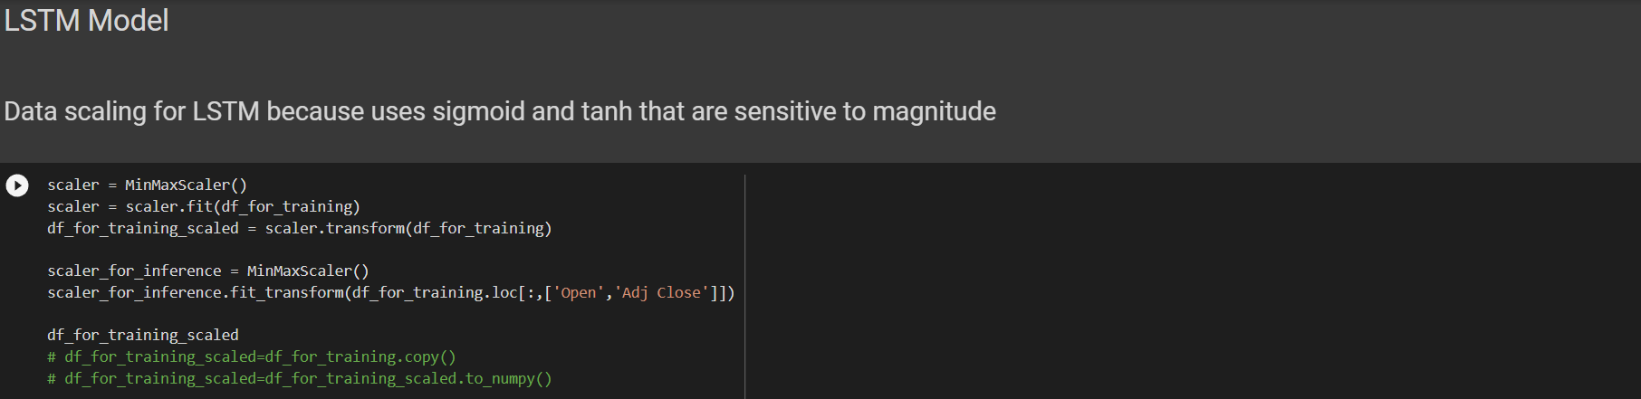

Model building: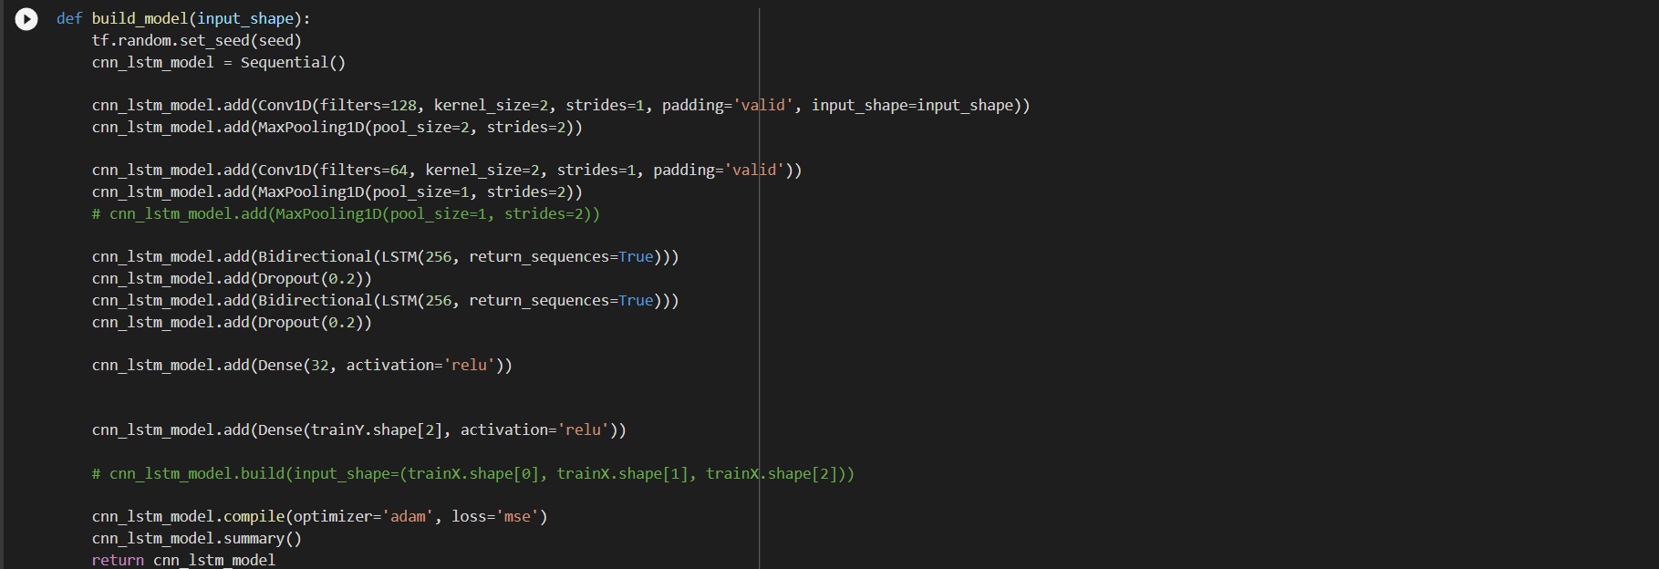

Validating the error on training data without twitter data :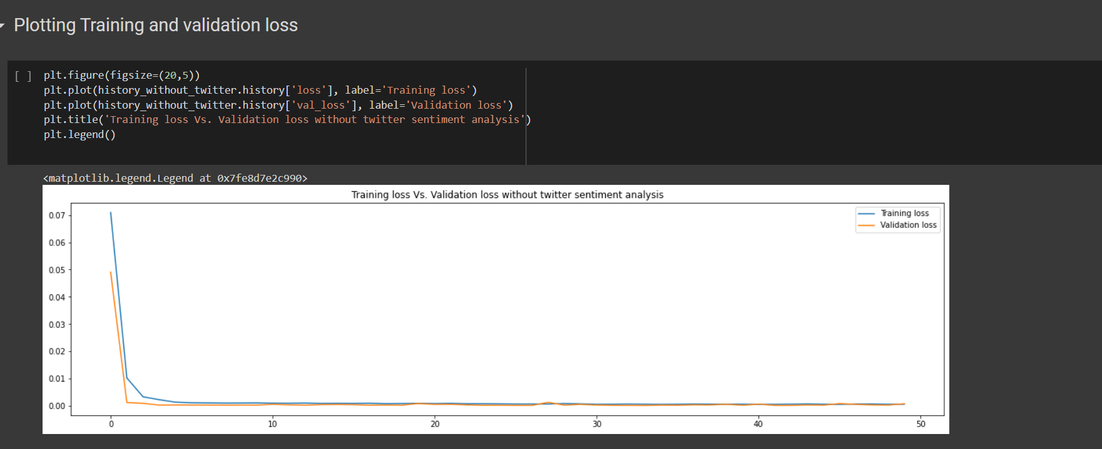
Validating the error on training data with twitter data :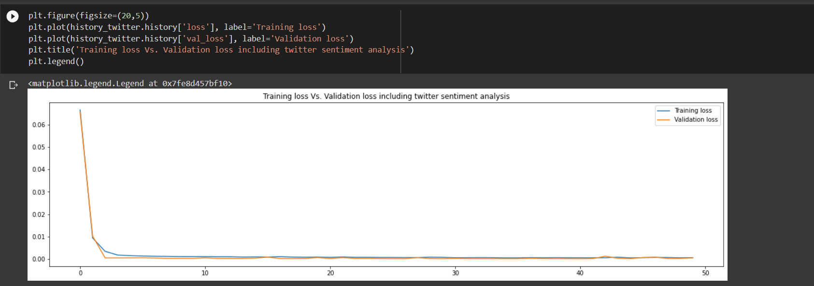Computing Accuracy: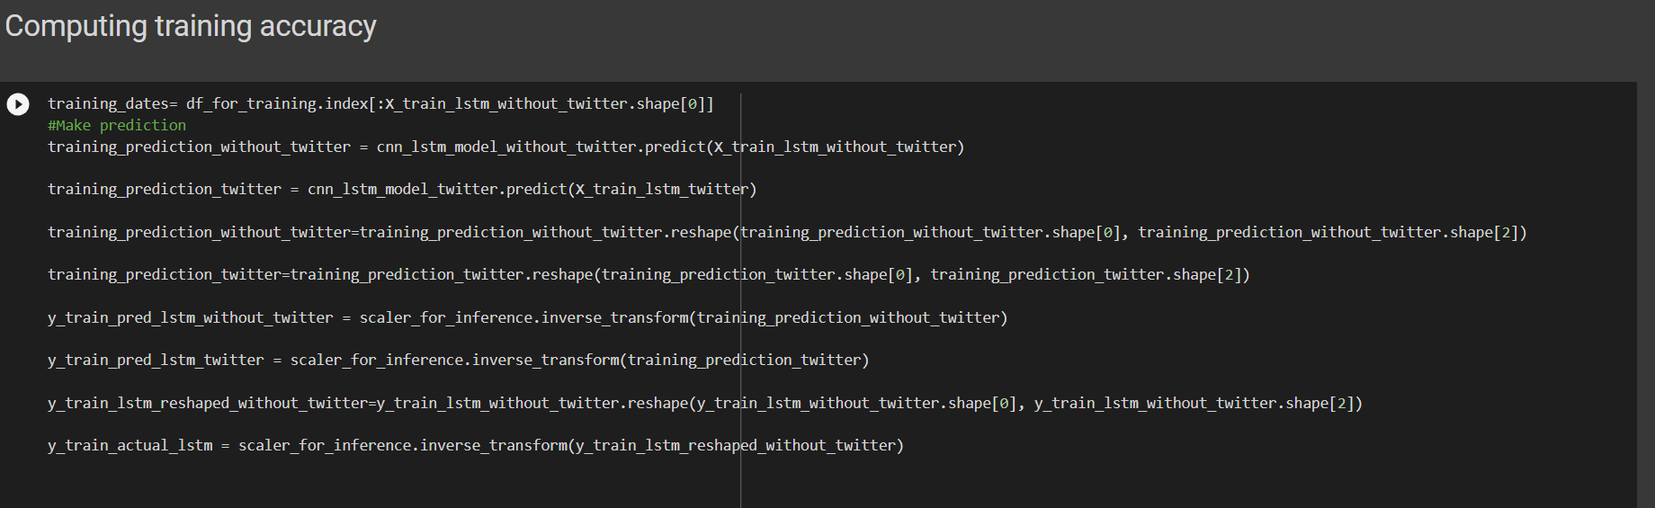
Final Outputs:
- Open without twitter data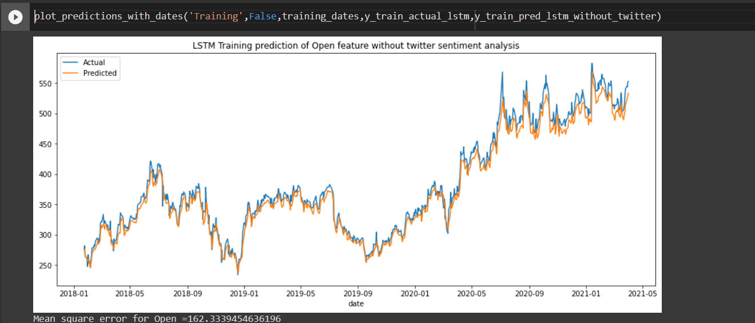
- Open with twitter data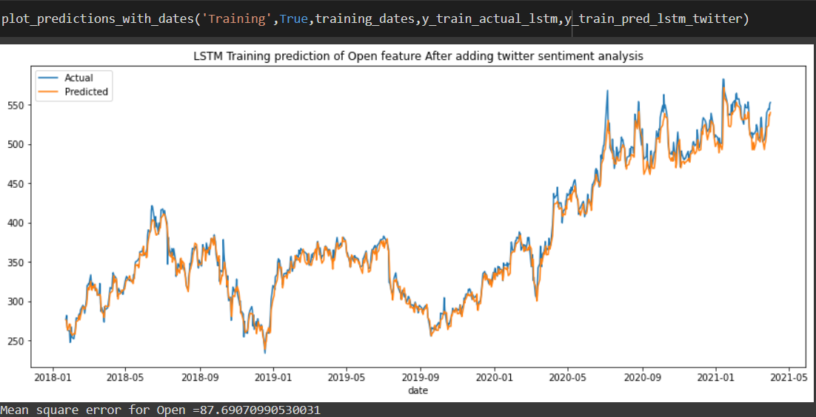

- Close without twitter data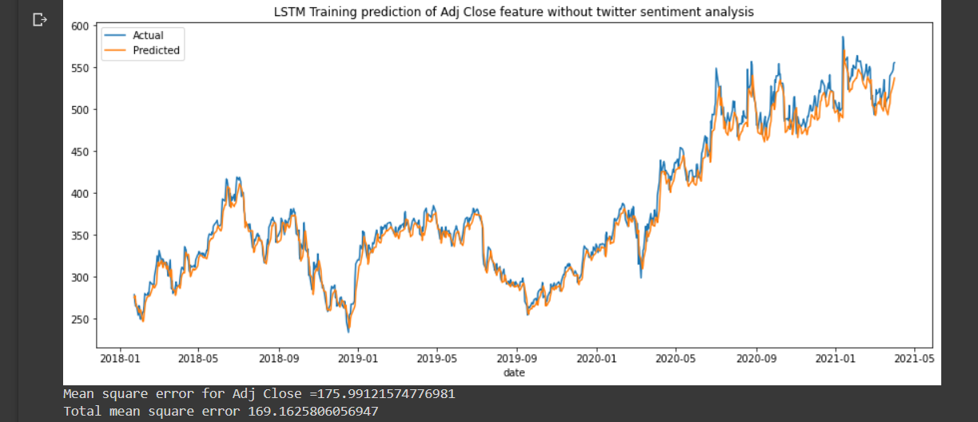

- Close with twitter data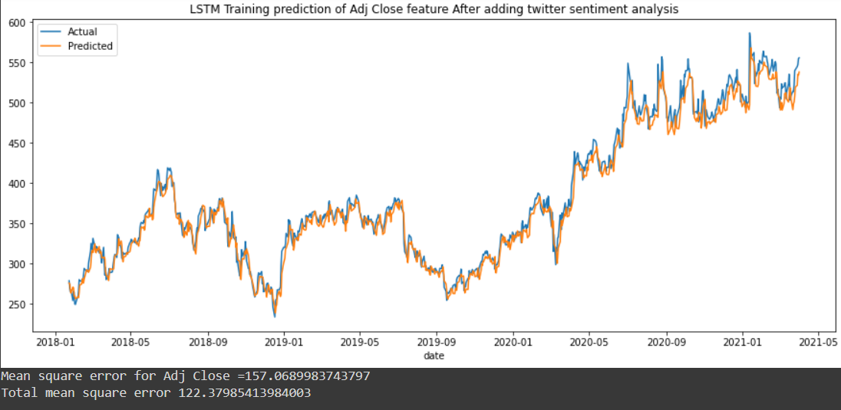
CHAPTER 9. CONCLUSION
In this study, we presented a new multichannel network for predicting stock prices based on high-demand stock (NETFLIX) selected by the size of their market capitalization. We ﬁrst employed the Natural Language Toolkit to perform sentiment analysis for text content in Twitter tweets to obtain insights into users’ sentiments about a particular stock. From classifying sentiment analysis results, we obtained an overall sentiment score for a given day for the stock. We then generated candlestick chart images based on historical time series data by using computer graphic techniques to visualize the daily price and stock movement for a given stock. These two types of data were input into our joint multi channel network. Our joint network consisted of two branches: (1) the ﬁrst branch included a LSTM without twitter data performing classiﬁcations based on sentiment analysis. (2) The second branch contained a LSTM with twitter data performing stock price prediction based on given data. The outputs of the two branches were concatenated and fed into a standard set of dense layers where the last layer computed the data and predicted the stock movement for the near future. The experiment results 23.53% 34.78% 62.31% 66.67% indicated that our proposed model achieved promising results for stock prediction and outperformed networks using either single sentiment data or candlestick charts alone. This indicates that using both types of data is more effective in the prediction of stock trends because both types of data can change and affect a stock’s price movement and traders’ decisions. The experiment results also indicated that the performance of stock prediction over longer periods of time achieved a more favorable result than did predictions made over shorter periods of time. Our proposed method achieved the most favorable performance with 75.38% accuracy for NETFLIX stock over a 10-day time period.

CHAPTER 10. REFERENCE

